FIELD REPORT ON UgIFT ASSET VERIFICATION

YUMBE DISTRICT
- The CAO was not around but he made clear communications to the DEO and the DHO about our coming early enough.
- We met with the DHO and told us about the health facilities under ugift which were;
- Kerwa health center III
- Mocha health center III
- Lobe health center III,
- Amanyiri health center III
- Nyori health center III
- Lobe health center III was not on the list from ministry but we visited it since the DHO had it in their records.
- Some instruments for amanyiri HC III were at district stores due to limited space at the facility
- We didn’t verify the instruments because they were packed in heavy solid wooden boxes
The DEO had the following schools under ugift program
- Kerwa seed secondary school
- Drajini seed secondary school and
- Lodonga seed secondary school
Some computers for Kerwa and drajini seed ss were at the district offices because th schools did not have complete computer laboratories

KERWA HEALTH CENTER III
The facility didn’t have an asset register but had inventory records
Some assets were engraved and some weren’t engraved
Incharge was new and knew less about the facility

CHALLENGES
The incharge was new and would find hardship identifying assets from ugift given the fact that not all assets were engraved
RRECOMMENDATIONS
Senior inventory management personnel must be maintained at the facility for proper inventory tracking
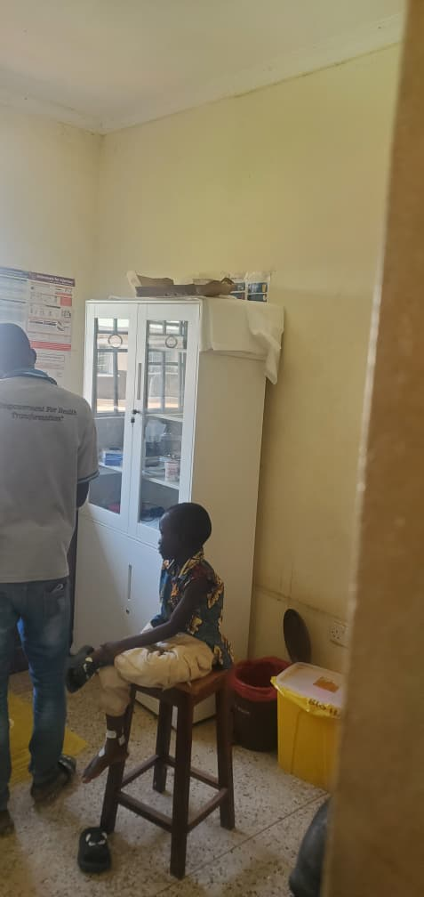
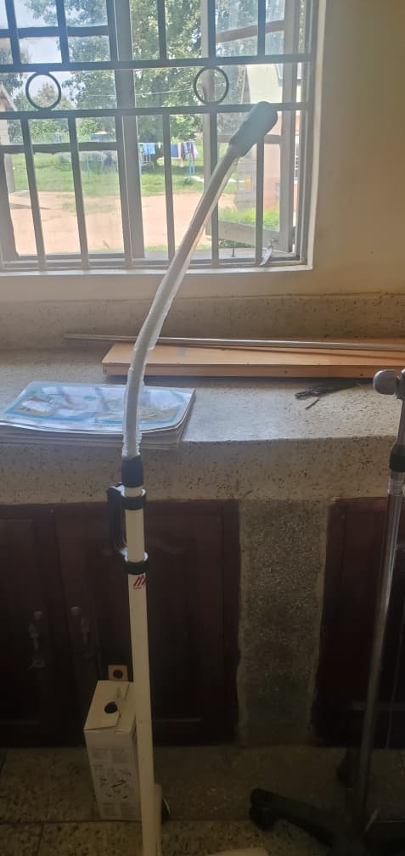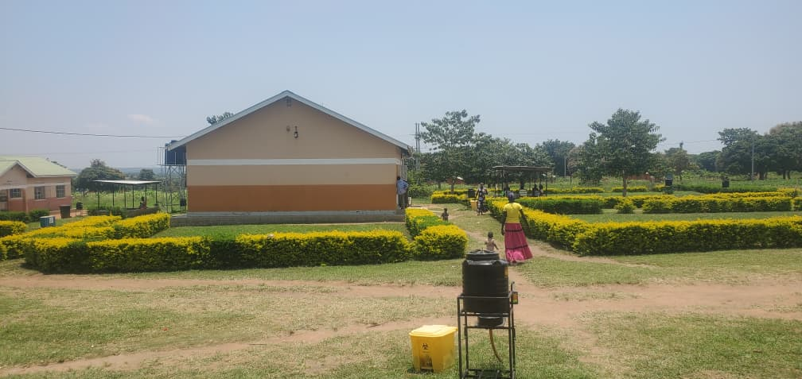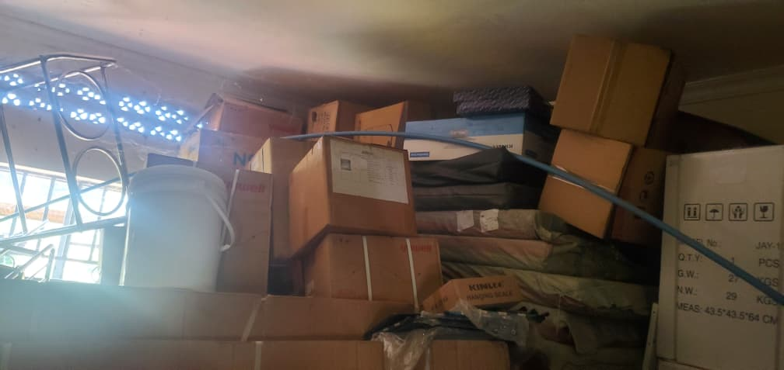

MOCHA HEALTH CENTER III
The facility kept records of the assets and delivery notes
The assets were not engraved
The incharge was on an annual leave but provided information over phone

CHALLENGES
The records were not well organized so we had to organize them to get accurate records

RECOMMENDATIONS
A professional records person is needed to make proper records and track inventory easily
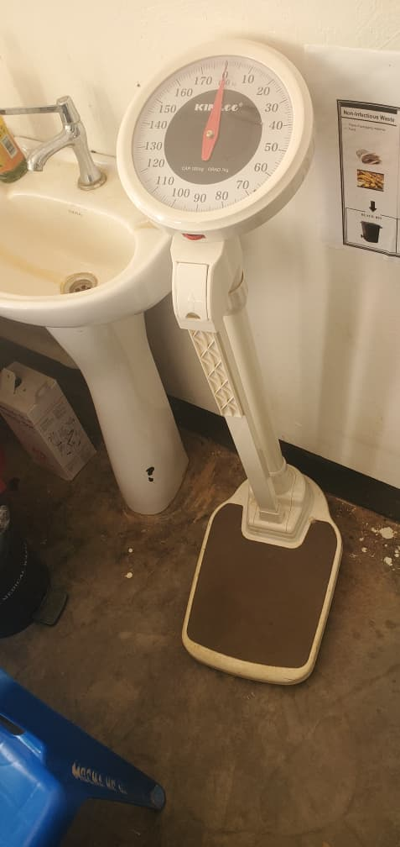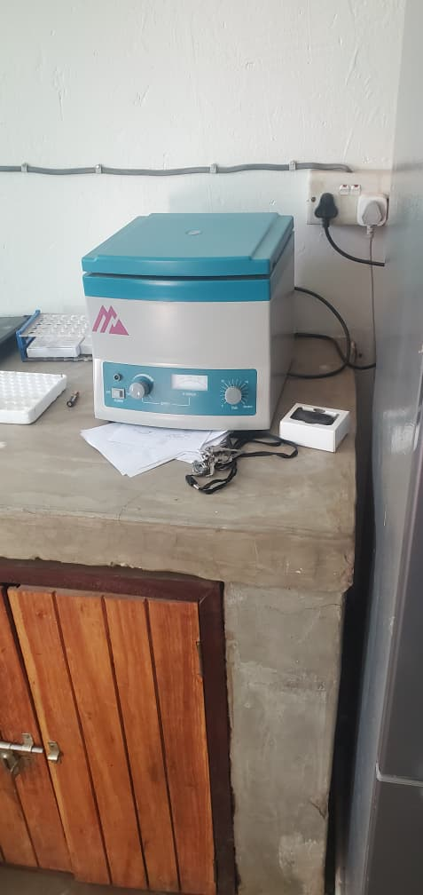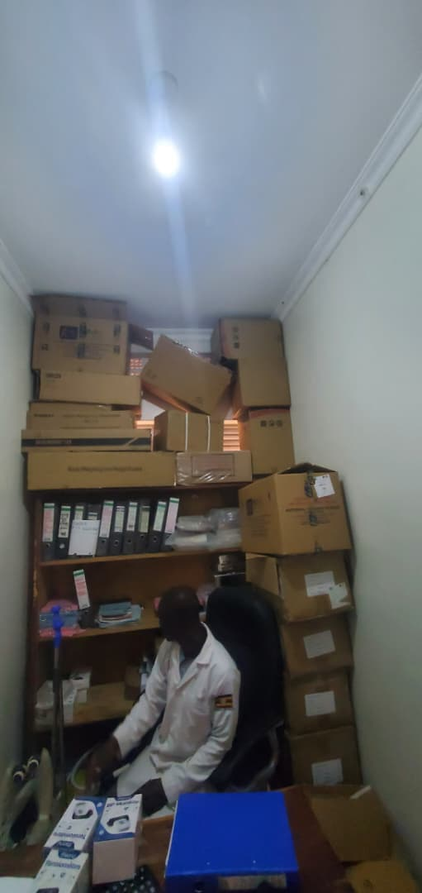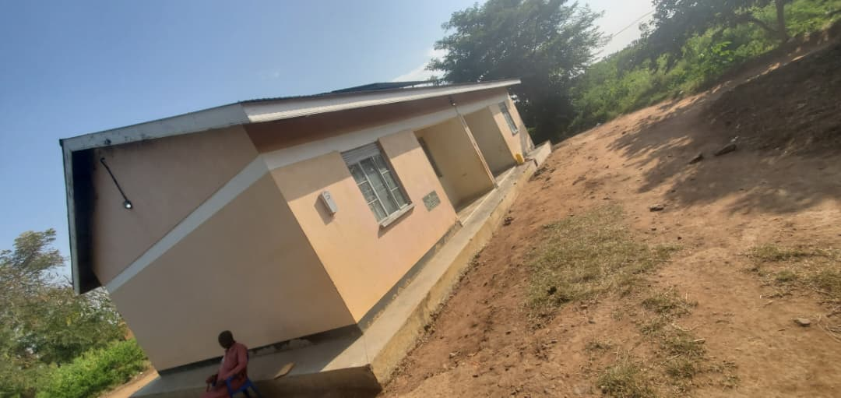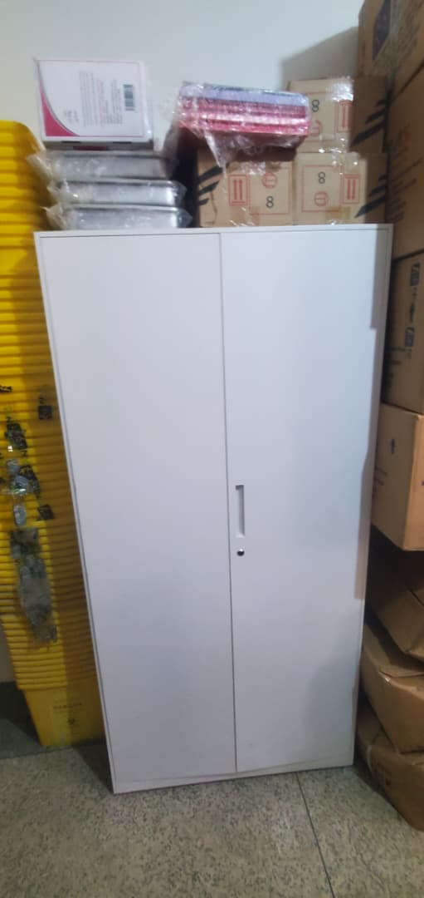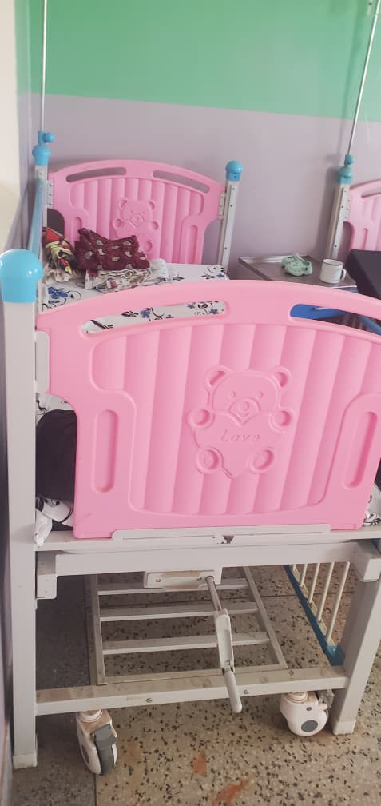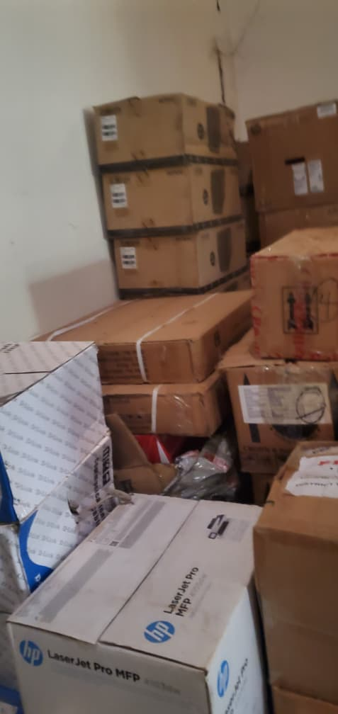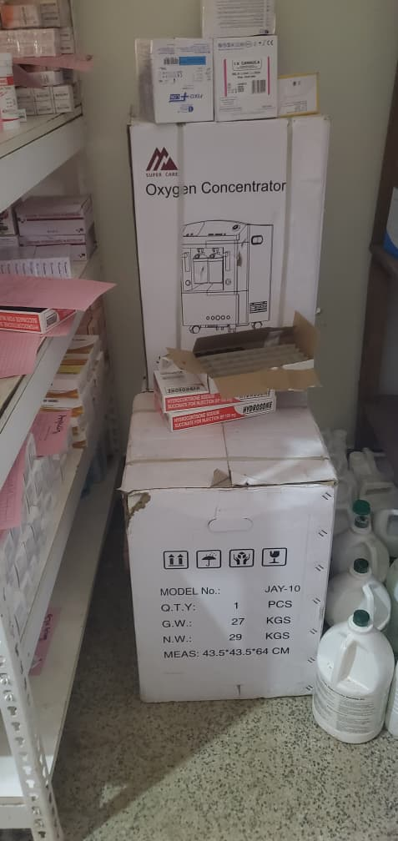

LOBE HEALTH CENTER III
The facility only has an OPD ward built by ugift which is empty and yet to start functioning
The facility does not receive any equipment from the ugift program
The incharge was new and had scanty information

CHALLENGES
The incharge was new in office and had scanty knowledge about the facility’s full back ground

RECOMMENDATIONS
Clear orientation of the new incharge before handing over office
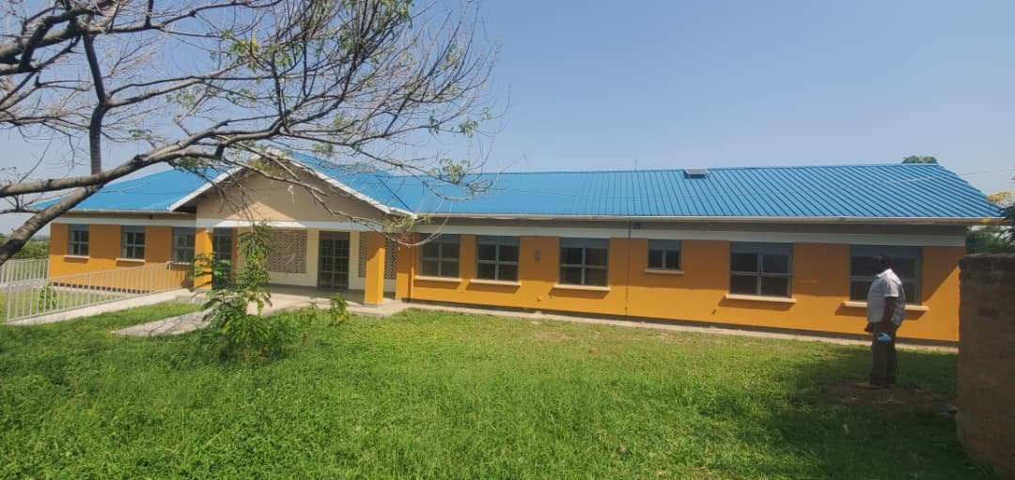
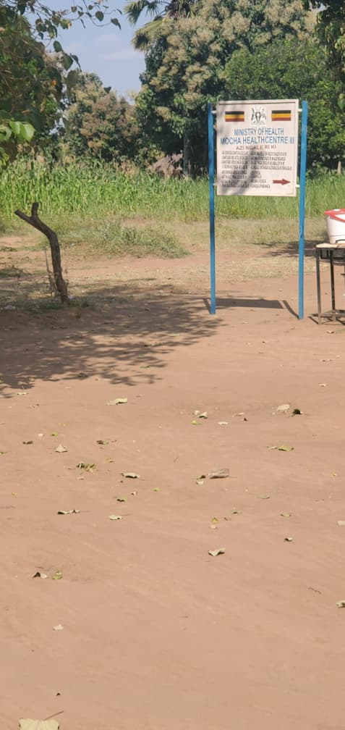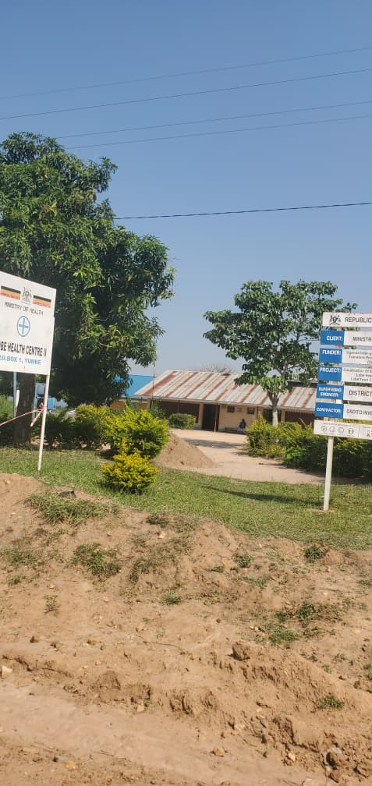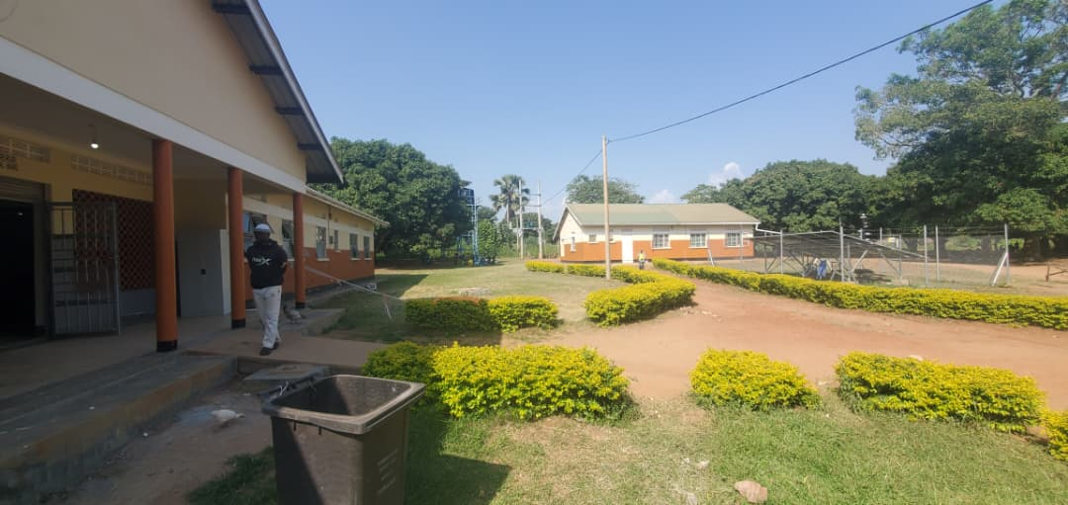

KERWA SEED SECONDARY SCHOOL
Headteacher was away in Kampala but delivered information over phone
There was a staff who helped us open the rooms for verification
No clear assets records were available, only school inventory records

CHALLENGES
The headteacher was new and wouldn’t give full information

RECOMMENDATIONS
Fully briefing the headteachers about the school and ugift program
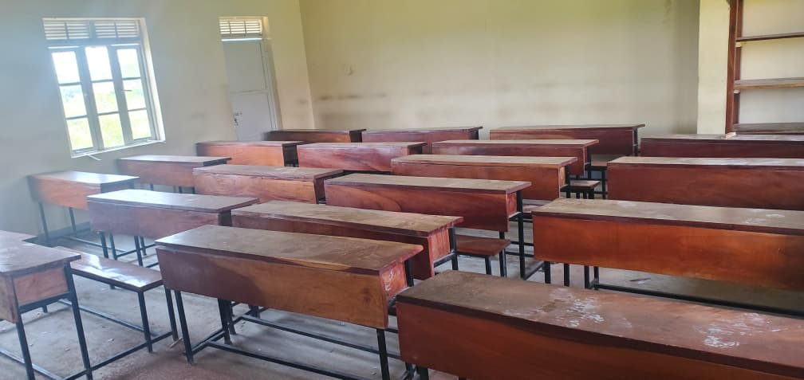
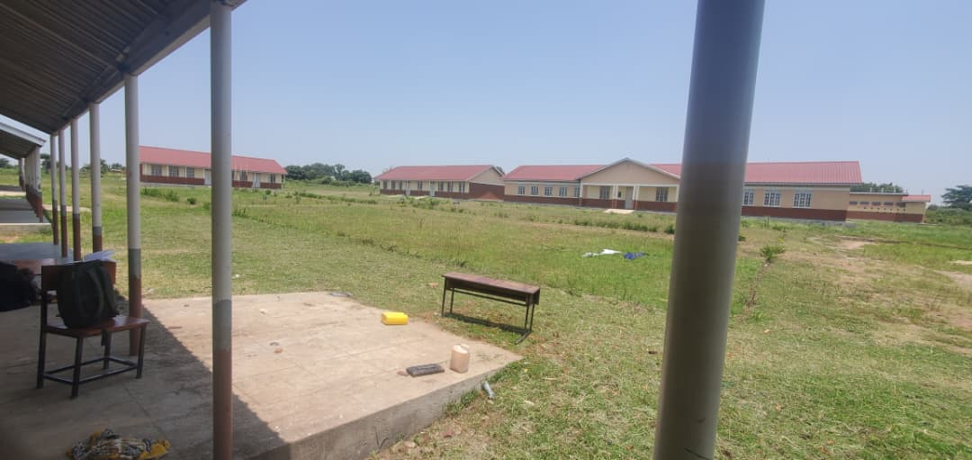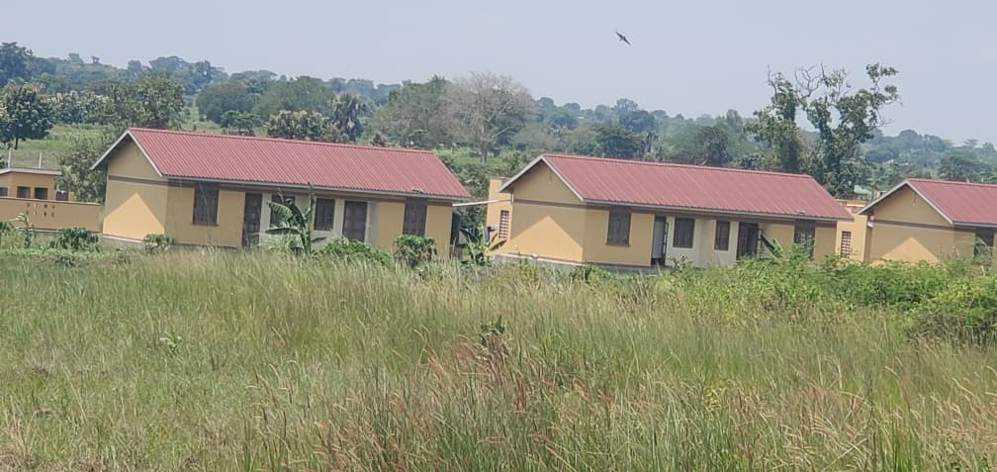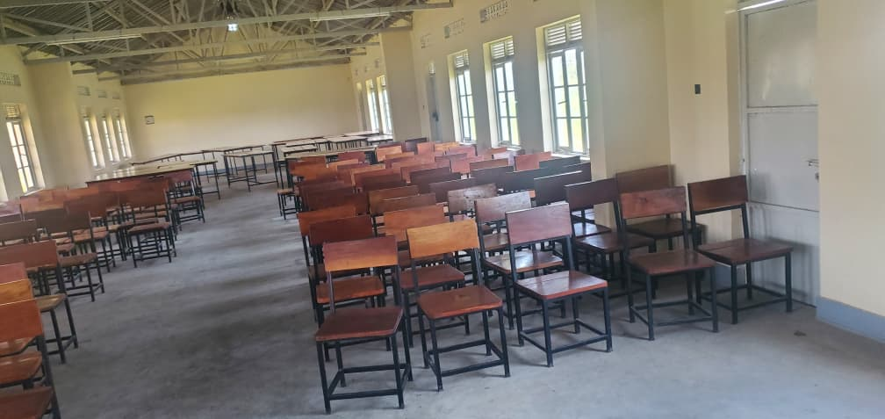

AMANYIRI HEALTTH CENTER III
The buildings were not yet in use and for that reason most of the equipment wasn’t picked at the district stores

CHALLENGES
The records were not organized to separate ugift records alone from other assets

RECOMMENDATIONS
Separate asset register should be put in place for ugift assets.

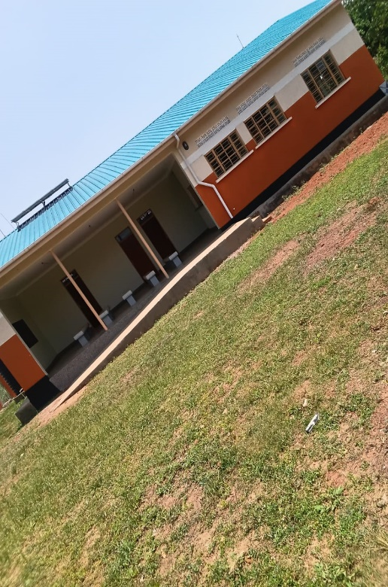
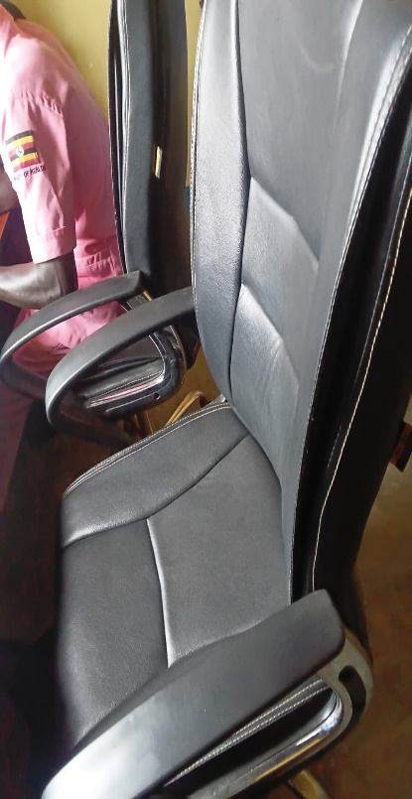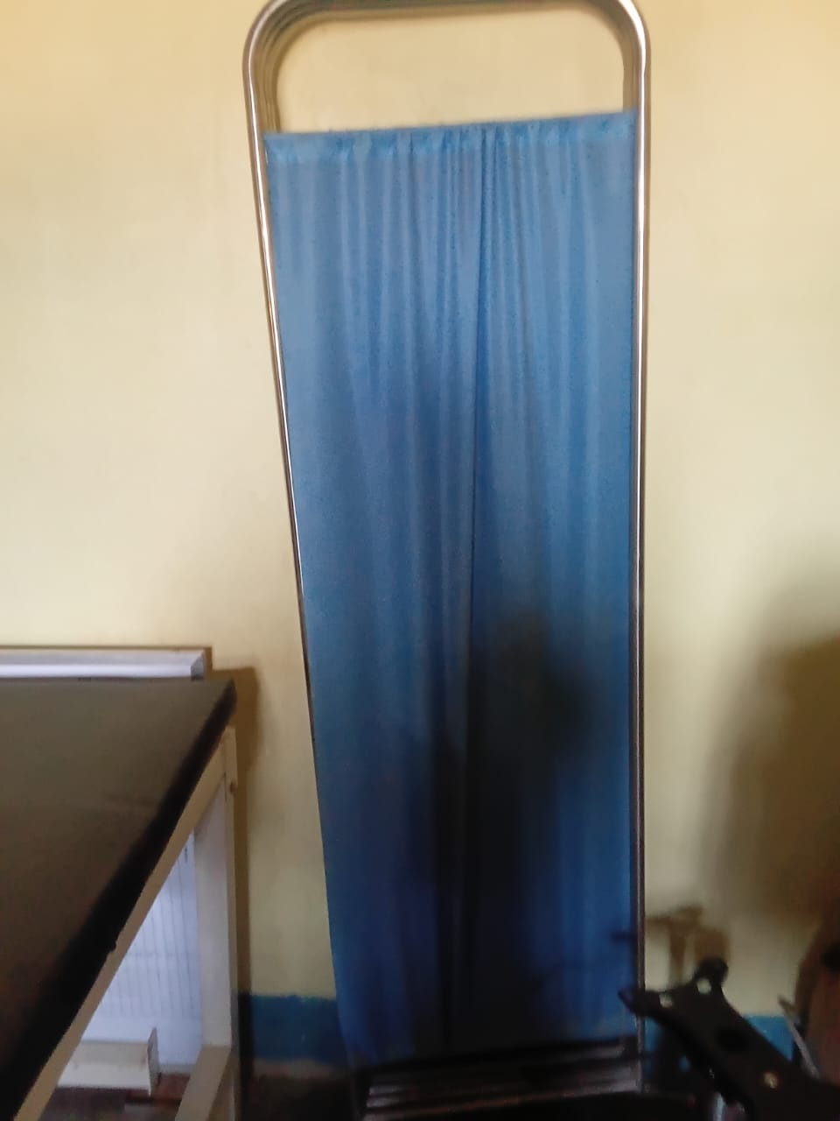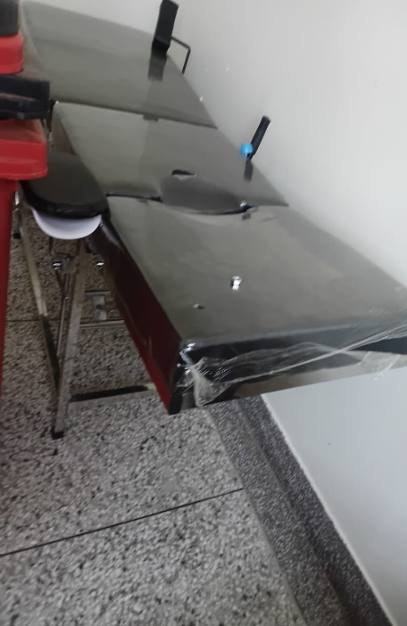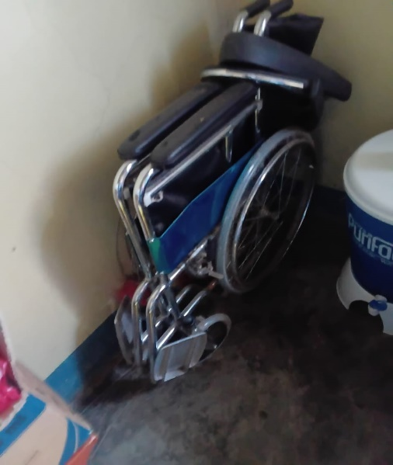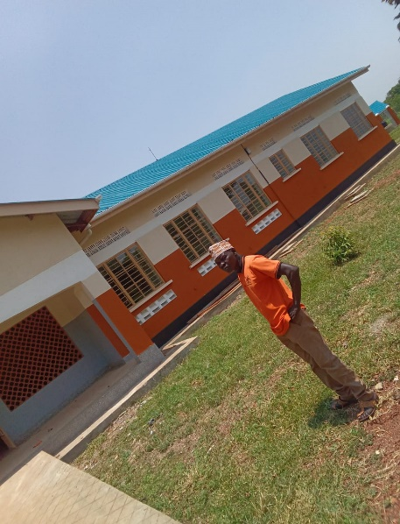

NYORI HEALTH CENTER III
The facility hand over was taking place soon officially
The in charge we found guided us through the facility

CHALLENGES
There was no separate ugift asset register and proper record keeping

RECOMMENDATION
Proper record keeping should be encouraged

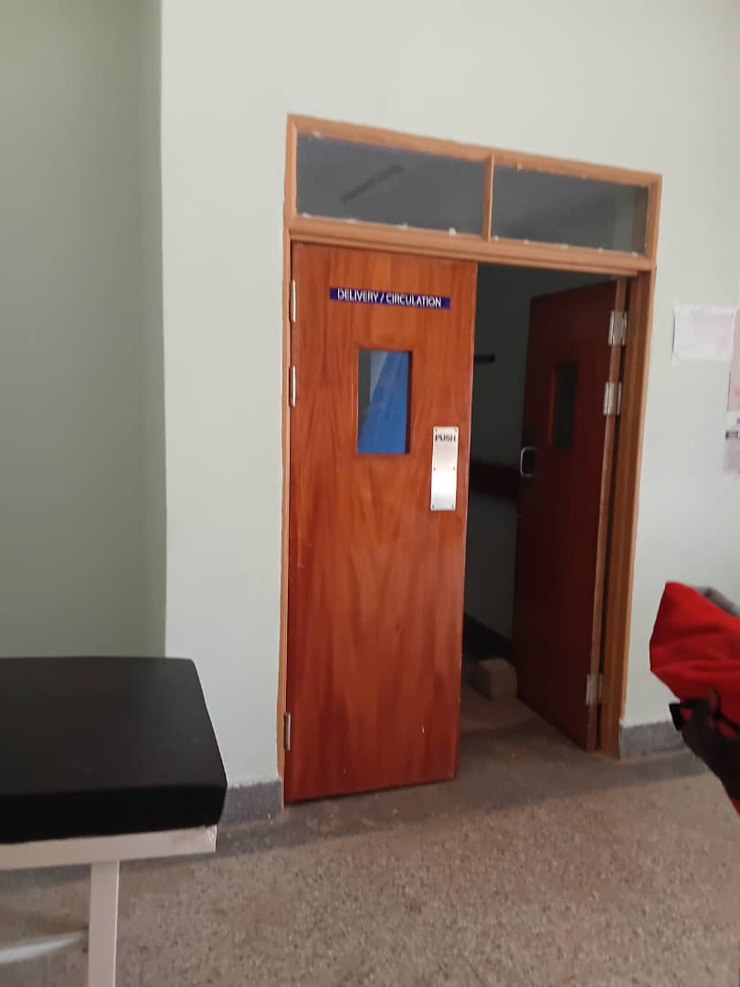
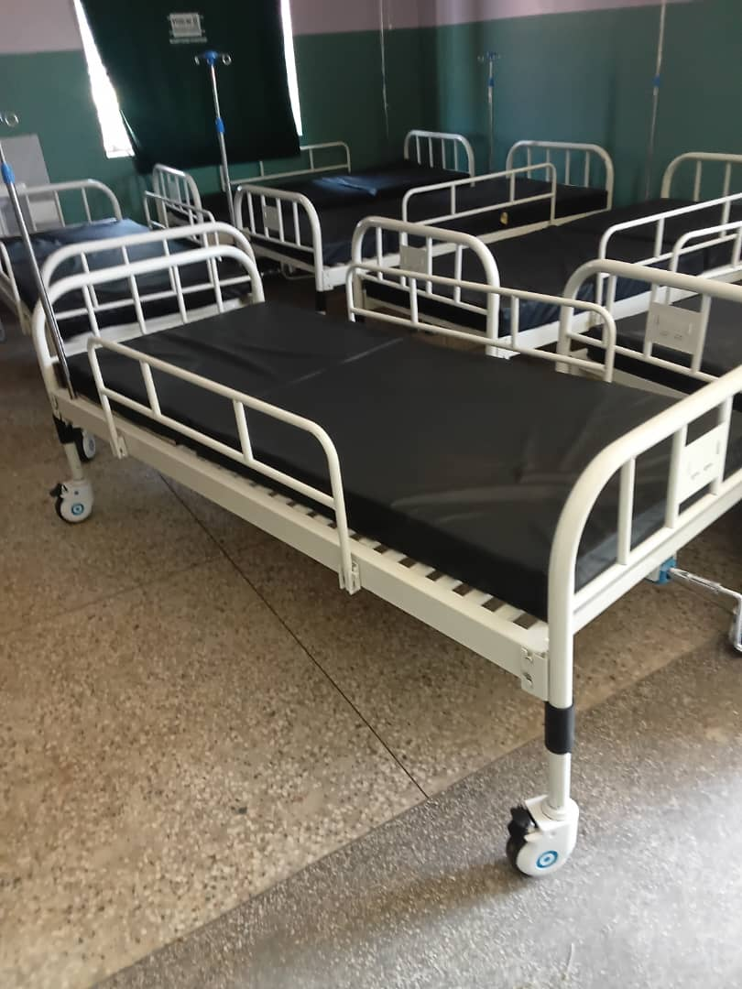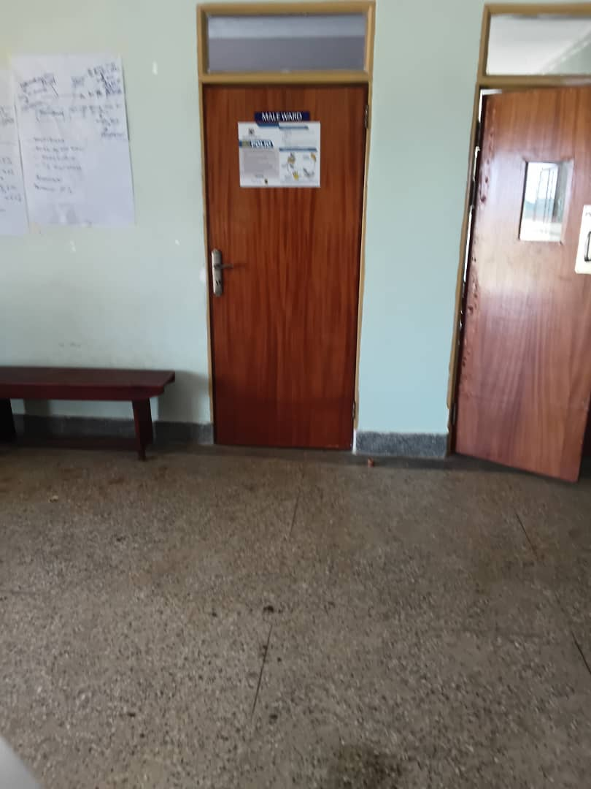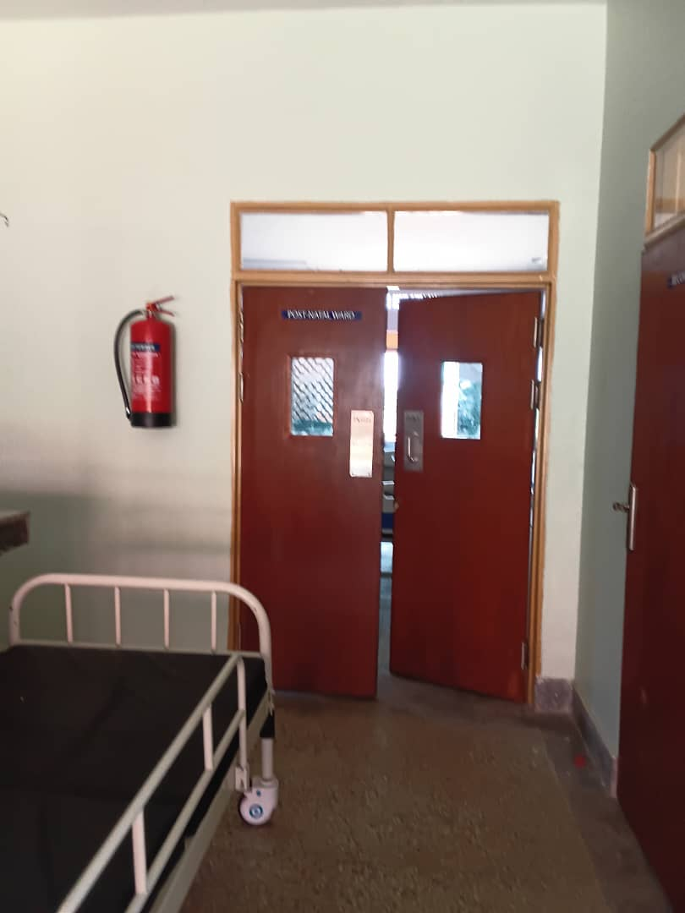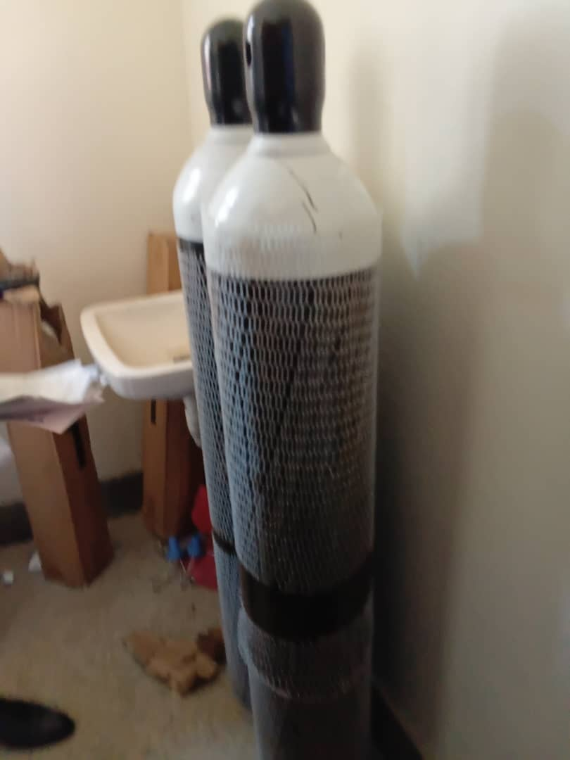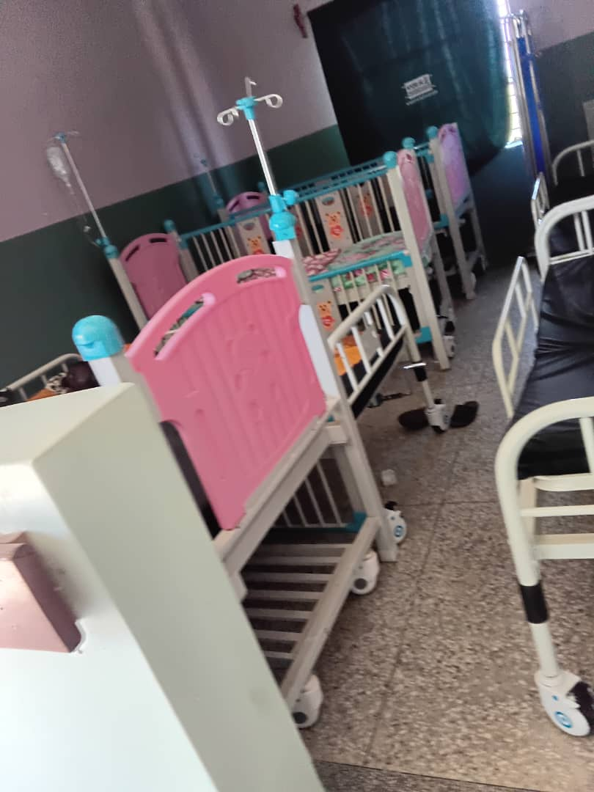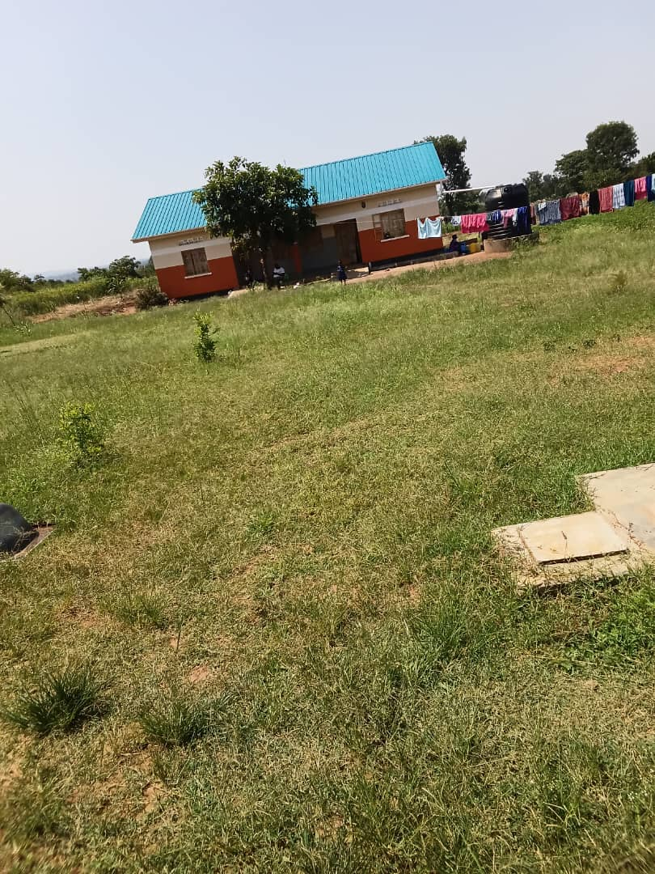

DRAJINI SEED SECONDARY SCHOOL
The assets were not engraved
Some of the ICT equipment were in the stores and not in use

CHALLENGES
The school didn’t have proper records kept

RECOMMENDATIONS
Keeping of proper records by the facility should be priotised for inventory tracking

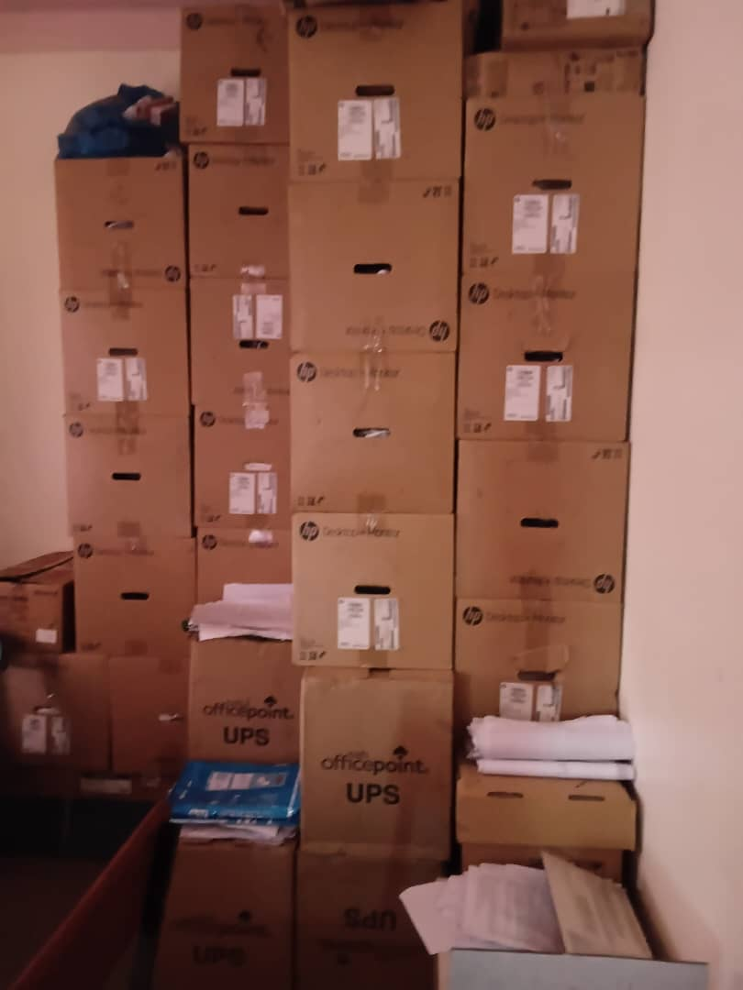
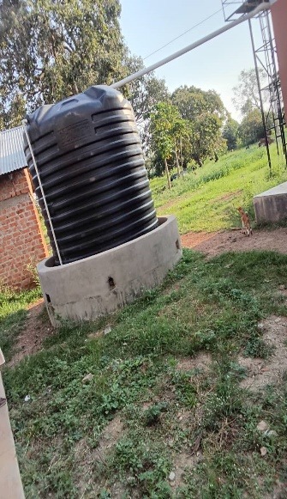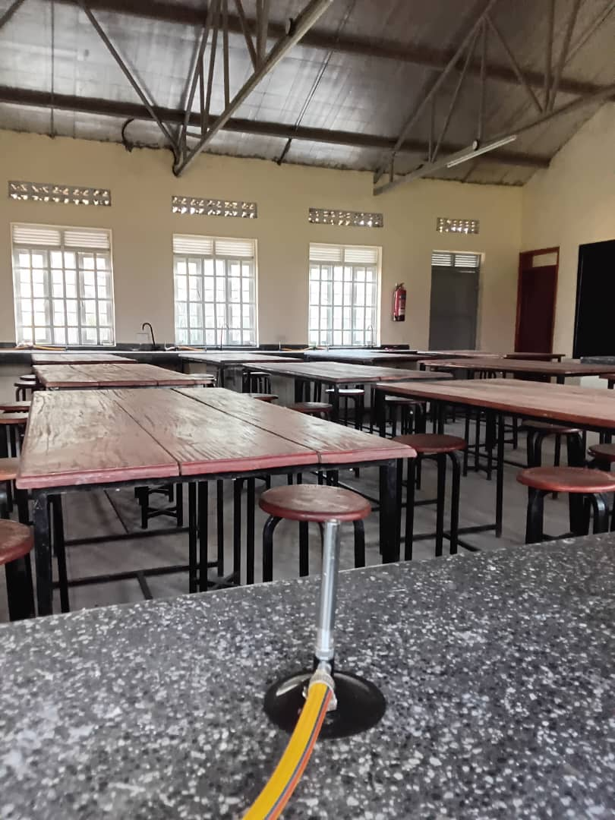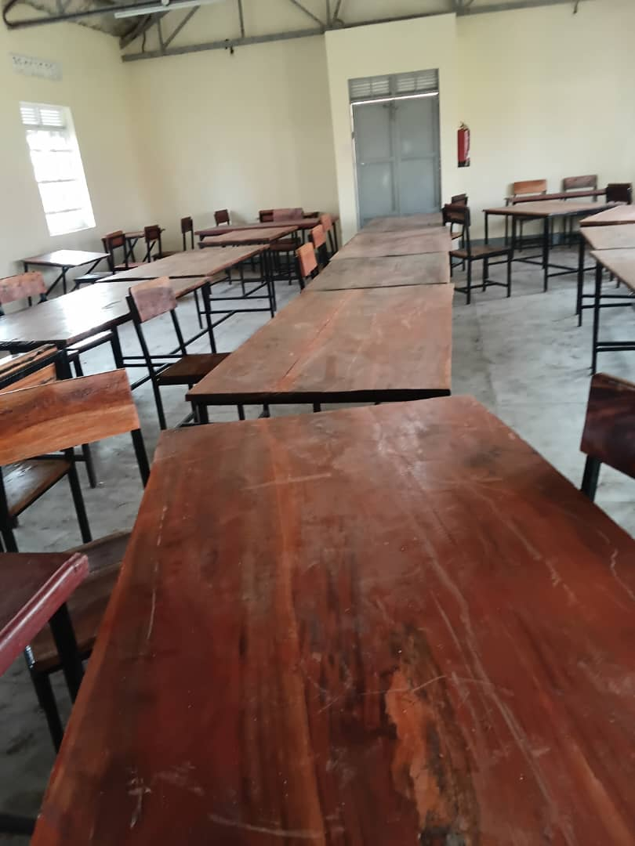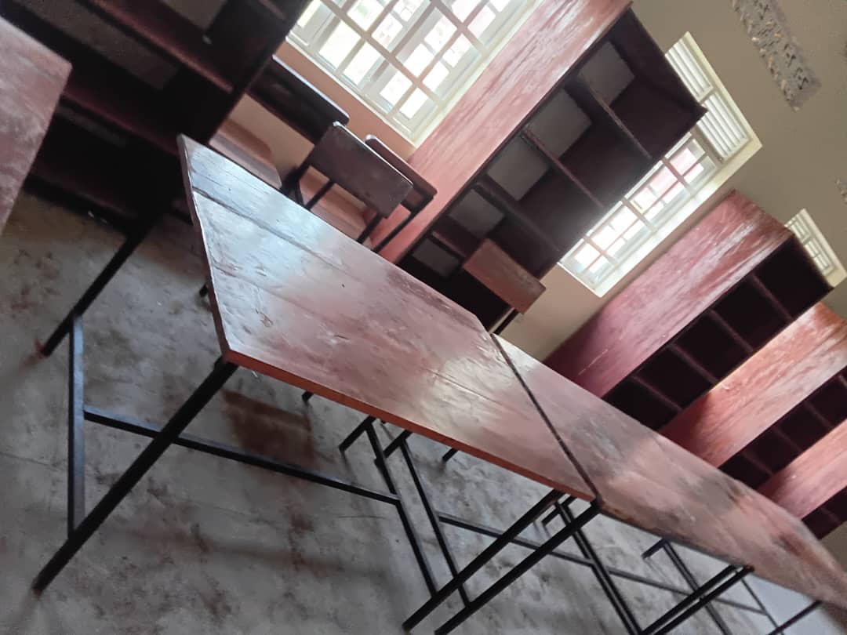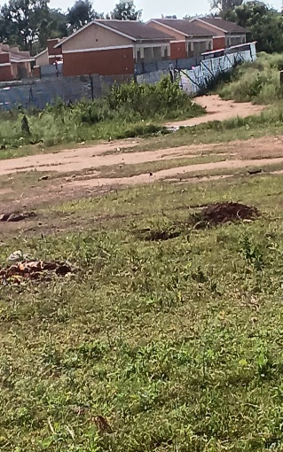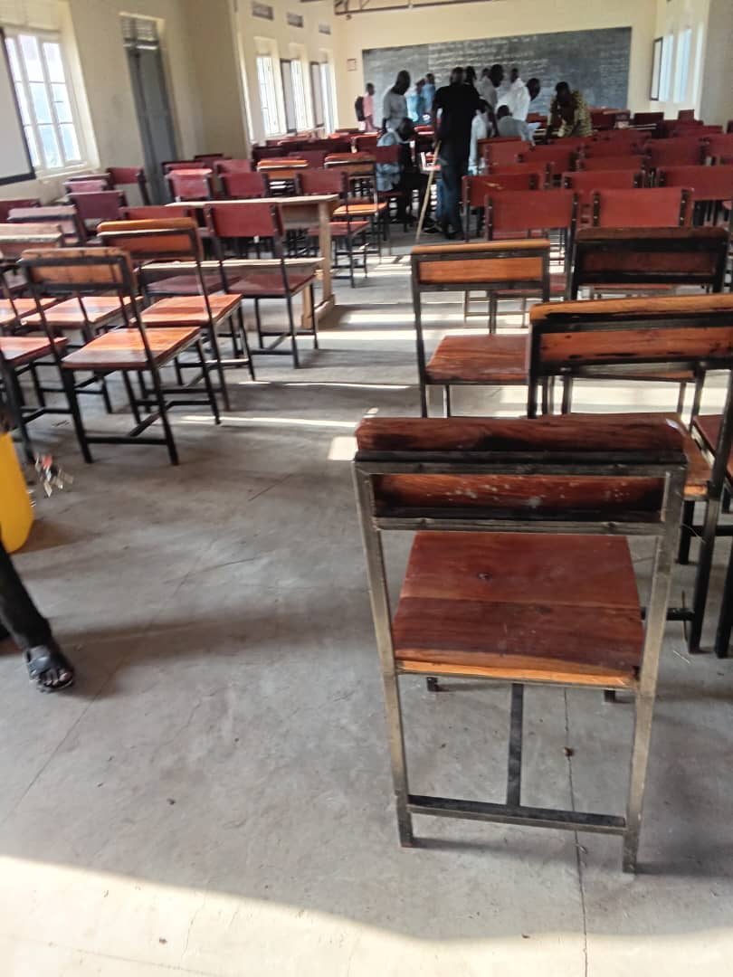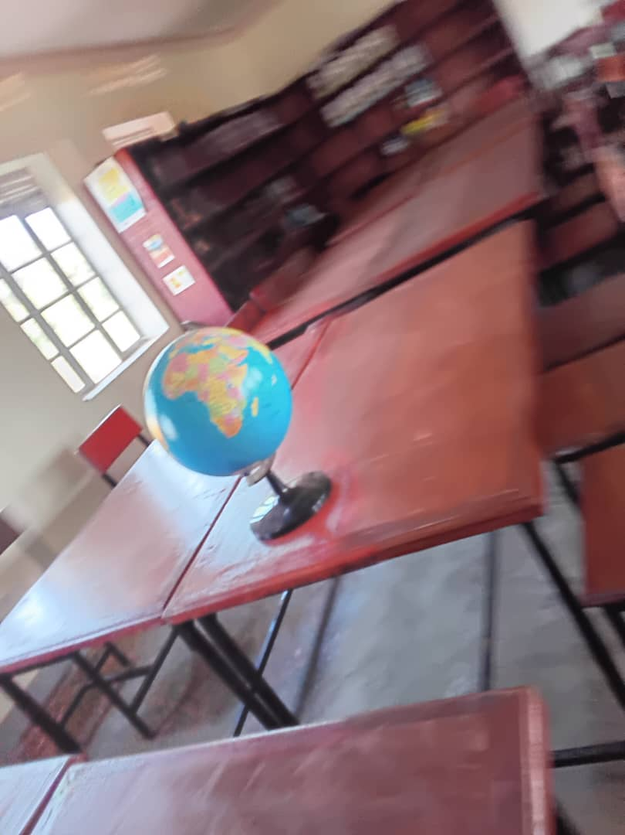

LODONGA SEED SECONDARY SCHOOL
The headteacher complained of the poor quality of chairs supplied by contractors and the tables were too high for students
Some of the work was still pending

CHALLENGES
The facility didn’t possess proper records for the assets supplied

RECOMMENDATIONS
Sensitizing the headteachers of the importance of record keeping

